The five absolutely best things to do in March
Here is where you need to go this month....
By Ray Mark Rinaldi, March 1, 2017

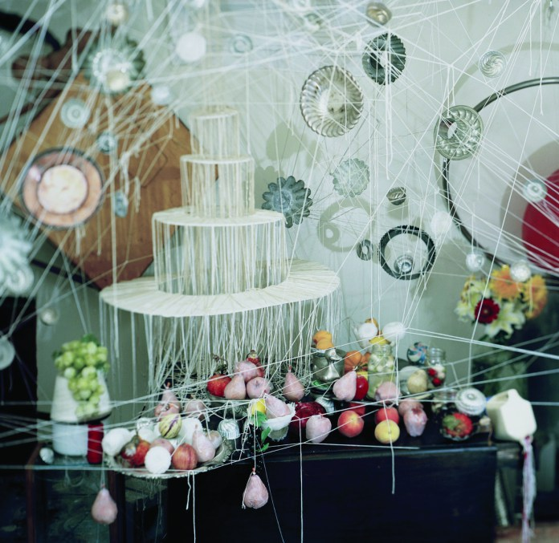
1. The Party:
MoP Opening Reception, RedLine, Saturday, March 11, 6-9 p.m.
There are scores of events on the calendar celebrating the sprawling Month of Photography but this opening of the signature show at RedLine promises to capture the spirit of every exhibit, lecture, workshop and whatever that’s in the lineup. The exhibit, “Between the Medium: Seeing Photographically” is promising, and it’s curated by Mark Sink, the force of energy that makes all things MOP happen.

2. The Movie:
“Maurizio Cattelan: Be Right Back,”
Friday, March 3, 4:30 p.m. Boulder Theatre.
Boulder’s Maura Axelrod has international cred as a journalist and filmmaker and her new documentary about contemporary artist Maurizio Cattelan is winning wide acclaim. Axelrod gets deep into the elusive artist’s head creating a striking portrait of the man whose workable, 18-karat gold toilet — titled “America” — has them lining up to go at the Guggenheim. The film screens as part of the Boulder International Film Festival.
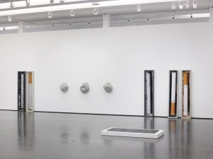
3. The Lecture:
Public radio’s Starlee Kine at RMCAD,
Thursday, March 9, 6:30 p.m.
This line from RMCAD’s press release sums it up: “Kine transforms audio into visually vivid stories that reveal the pitfalls and triumphs of curiosity, discovery, and human universality.” The program she turned into a hit, “Mystery Show,” was named best podcast of 2015 by iTunes. That means she can talk — so go listen.
4. The Day Trip:
“Adam McEwen: I Think I’m in Love,”
now through May 28, Aspen Art Museum.
Adam McEwen is probably best-known for his fake obituaries of famous living people, which say as much about the undead as they do about our infatuation with a certain kind of celebrity. Aspen has the New York–based Brit in his first solo show, which includes, among other objects, some curiously large cigarettes.
5. The Mind Trip:
Solo works by Nika Kaiser,
Friday, March 10, 7:30 p.m., Dikeou Pop-Up.
Nika Kaiser is a Tucson-based video artist whose dreamy creations connect the natural and logical to the spiritual and completely outrageous. Her short pieces are trippy mysteries your can’t stop staring at. Brought to you locally by Collective Misnomer.
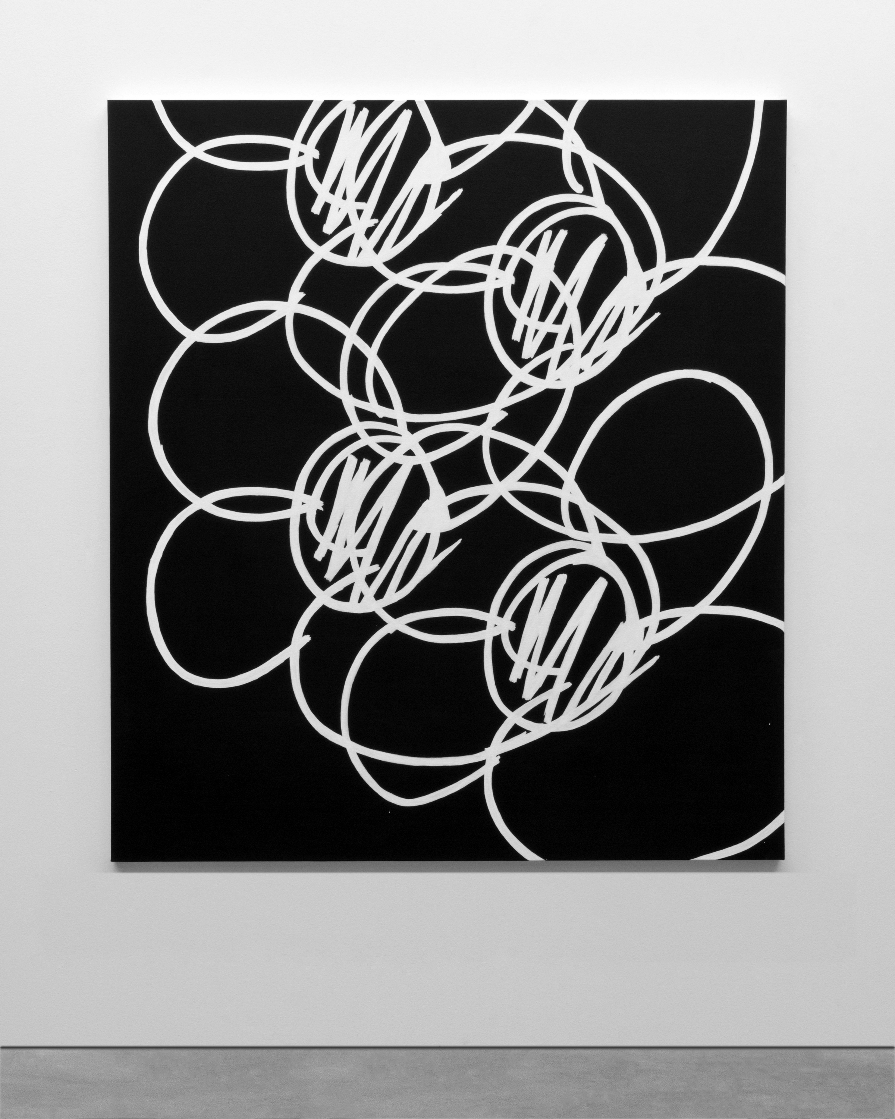
Bonus!: Five other surely cool things to check out:
1. Joseph Coniff Times 2:
His own solo show at Rule Gallery has an opening Saturday, March 4. But the show he’s curating at Leisure gallery across the street, opens the night before on Friday, March 3.
2. Denver Artists for Rent Control Public Forum
on the afternoon of March 5, Mercury Cafe. This effort would have seemed less logical even a few years ago. Not anymore.
3. Jon Geiger and Dmitri Obergfell
talk about installing really, really big works on Wednesday, March 8, at BMoCA.
4. Aftershock,
a party and fashion show hosted by DAM Contemporaries. It’s pricey, but the museum’s fashion curator Florence Müller will be there, so, you know, pay whatever. Thursday, March 9, at the museum.

Coniff? Photo? Go see
5. Lisa Kereszi and Benjamin Donaldson
each talk about their super-happening work at the Dikeou Collection, March 16. DAM’s curator Eric Paddock leads a chat after and it’s all tied into Denver’s rip-roaring Month of Photography at, like, a lot of places across the region.

