11 Photographers to check out during
Denver’s Month of Photography
By Cori Anderson, February 24, 2017

Denver’s biennial celebration—Month of Photography— is coming up in March and April at hundreds of locations across the Front Range. RedLine Contemporary Art Center will be the main hub where multiple lectures, exhibitions, portfolio reviews and workshops in partnership with Colorado Photographic Arts Center (CPAC) will take place. For the most public display during Month of Photography, CPAC and Denver Digerati have curated a series of local photography to be showcased on the giant LED screens that are part of the Denver Theater District, at 14th and Arapahoe and at 16th and Champa.
The 2017 Month of Photography celebrates the “far-reaching applications and concepts emerging in photography today” according to the official website. This year the theme is Between the Mediums—Seeing Photographically which will allow for many different galleries, museums and businesses to display work that may not prescribe to traditional definitions of photography, but which explore the use of photographic materials and techniques in an artist’s practice.
With so many participating venues the choices feel overwhelming, so 303 Magazine decided to highlight some of the most exciting exhibitions that will be celebrating Denver’s Month of Photography, splitting them into five categories for better navigation and sorted by artist.

Abstract
The Art of Scanning
What: Juried exhibition that requires artist use the art of scanning as their primary medium
When: March 17—April 15, Wednesday-Friday, 1—5 p.m. (except 1st and 3rd Fridays), Saturday 1—4 p.m.,
Where: Niza Knoll Gallery, 915 Santa Fe Dr, Denver
The Lowdown: Embracing the theme of Denver’s Month of Photography— Between the Mediums— Niza Knoll asked artists entering in this juried exhibition to capture art through a scanner instead of a camera. The scanbed will act as a lens, light source and canvas. The call for entries explains that there are many different techniques with scanner art and urges artists to be as creative as possible. With so much creative freedom, the results are bound to be fascinating.

Joseph Coniff
What: Basic Pictures, art using photographic tools and materials in unconventional ways by Joseph Coniff
When: March 4—April 15,
Where: RULE Gallery, 530 Santa Fe Dr, Denver
The Lowdown: Though the finished pieces of Joseph Coniff‘s exhibition, Basic Pictures are paintings, the process which brings him to that point involves scanning images and editing them digitally which are ultimately photographic techniques. He begins with bold lines using markers and eventually crops, zooms, recomposes and colors the images to produce a different perspective altogether. As the press release states, “this [exhibition] harkens back to the photograms of Man Ray: darkroom works where the artist bypassed the middle-media of negatives by layering objects directly onto photographic paper, resulting in collaged imagery that can vary from ghostly to sharp, to surreal and dreamlike.” This kind of photographic display is for the open-minded.
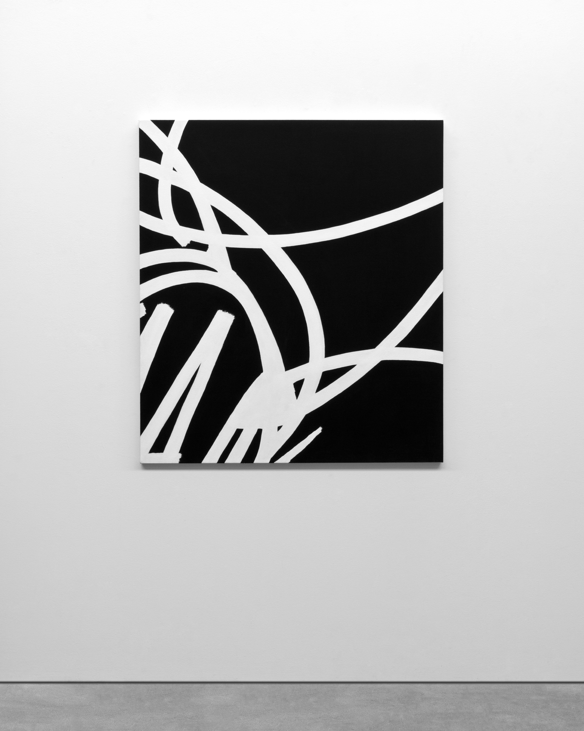
Joseph Coniff, Four Flowers (in details), 2016, acrylic and enamel on canvas, 40.5 x 36 inches

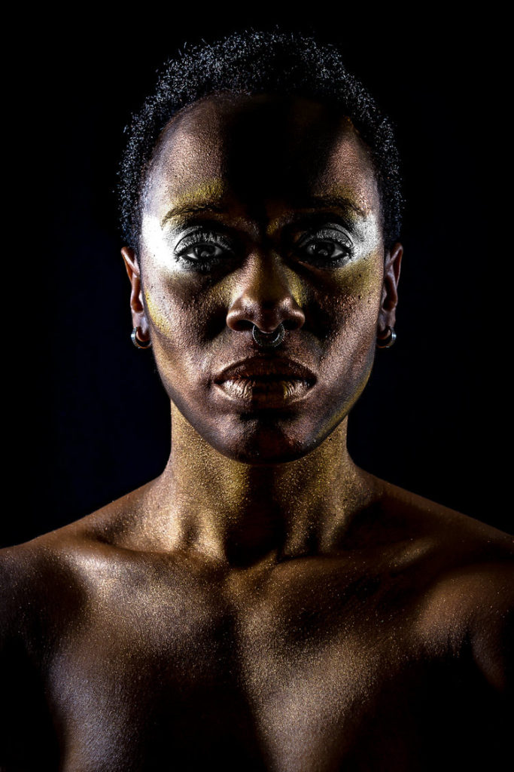
Portraiture
Tya Alisa Anthony
What: SKINs, “a photographic exploration of the complexities of American culture in the 21st Century”
When: March 11—April 8, Wednesday-Friday, 12—7 p.m., Saturday-Sunday, 12—5 p.m.
Where: Leon Gallery, 1112 East 17th Ave, Denver
The Lowdown: Tya Alisa Anthony is a Denver-based artist who presents social, environmental, cultural and political narratives with her work. SKINs— a photographic exhibition shown at Leon Gallery—will examine the idealization of body image, both physically and metaphorically. About her work, Anthony explains, “I create visual personifications of identity narratives through photography, drawing and mixed media. I explore the gaps of knowledge of my own heritage with vivid imagery addressing a once declared chameleon identity… I am most interested in metaphoric masks worn as protection and representation of Identity.” These particular pieces were inspired by organic colors and textures and natural weathering processes that relate to aging.
Tya Alisa Anthony
Ken Hamel
What: Denverarts.org—A Decade in photographs by Ken Hamel
When: Opening reception March 3, 6—9 p.m., March 4, 1—5 p.m., April 7, 6—9 p.m., April 8, 1—5 p.m.
Where: VERTIGO Art Space, 960 Santa Fe Dr, Denver
The Lowdown: Ken Hamel started Denverarts.org in 2007 as a complete online resource of art events in Denver, where someone could go to find the details about every artistic endeavor happening, as well as reviews and photos. In the decade that followed, Hamel collected thousands of photographs of Denver artists after attending thousands of art exhibitions. With the help of the photographer Anthony Camera, Hamel chose 40 of the best portraits from the last decade and will be displaying these at VERTIGO Art Space as part of the Month of Photography celebration. Though told through photography, this exhibition will surely be an ode to the artists of Denver, no matter what medium they express themselves through.

Realism
Armando Martinez and Shana Cordon
What: Feral Factory‘s urban photographic survey by Armando Martinez and Shana Cordon titled Exploring the Collage City (See 303 Magazine’s announcement about this exhibition here).
When: February 24—March 30
Where: The Crash, 2555 Walnut St, Denver
The Lowdown: Photographs by Armando Martinez and Shana Cordon reveal intimate and astute observations about urbanism which break down typical understandings of living in a city and how that effects all of us. Their collection is the first in a series of exhibitions by Feral Factory that will run through the summer. They also have a call for entry until February 25 at midnight for guest appearances in this show.
Ryan McGinley

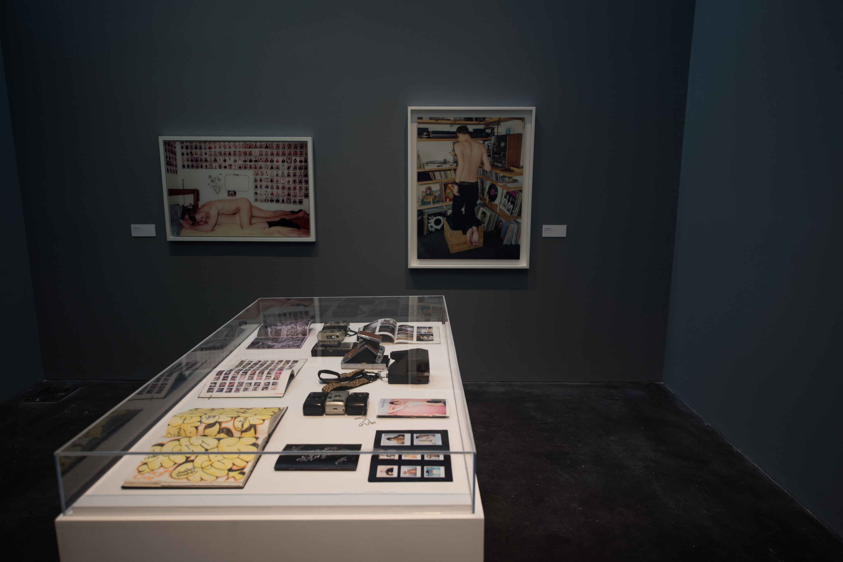
What: Ryan McGinley’s The Kids Were Alright, presented by MCA Denver
When: February 11 - August 20. Tue-Thur, 12 - 7 p.m., Fri 12 - 9 p.m., Sat-Sun, 10 a.m - 5 p.m.
Where: Museum of Contemporary Art, 1485 Delgany St, Denver
The Lowdown:
The Kids Were Alright features early photographs by Ryan McGinley in Manhattan in the 1990s, which includes never before printed pictures, the actual point-and-shoot cameras he used to take pictures and an impressive band of 1,763 Polaroids in three rows wrapped around the entire floor, depicting visitors to McGinley’s apartment over a four year period. The photographs are gritty, uncensored and candid. Read our entire review of his show here.
Installation View from The Kids Were Alright, MCA Denver
John Furlong

What: Jon Furlong’s photographs of street artist Shepard Fairey and his indoor/outdoor work
When: March 11—March 31. Opening reception March 11, 7—9 p.m.
Where: Black Book Gallery, 304 Elati St, Denver
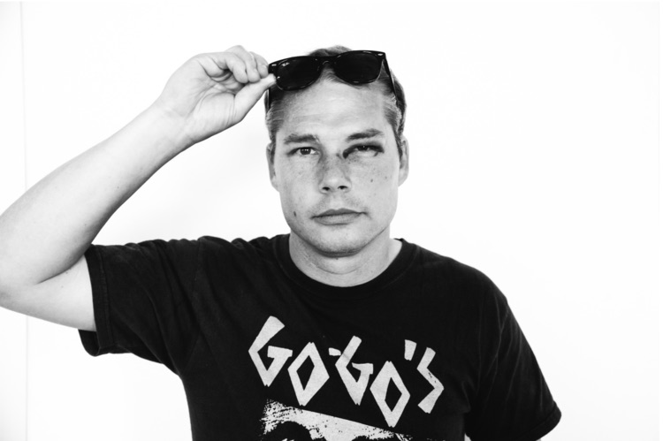

John Furlong, Shepard Fairey

The Lowdown: According to Furlong, “the art of photography is preserving moments for eternity”—a technique that focuses on presenting an unadulterated truth rather than trying to create meaning out of an image. Perhaps this style comes from Furlong’s subject matter—Shepard Fairey and his art, which have plenty to say for themselves—but perhaps it’s a matter of historical record more than anything else. Furlong hopes to turn an abstract moment into a physical image that represents impermanence itself. He manages to capture the images because he is officially Fairey’s personal photographer.

Interactive
The Painted Pixel
What: Personal Portrait Transfer into modern tintype
When: March 3, 7—10 p.m.
Where: The Painted Pixel, 5227 West 25th Avenue, Edgewater, Denver
The Lowdown: The Painted Pixel is an art gallery and high quality print shop that will be presenting work by “Colorado Josh” Hicks, David Jepson and Christopher Kates during Denver’s Month of Photography. That exhibition, titled Alternative Printmakers will be on display from March 3 into April and focuses on modern photo transfer techniques onto various media. On opening night, The Painted Pixel will be offering wine and snacks as well as an opportunity to have your portrait taken and transferred into a modern tintype (pictured above.)

DAM Month of Photography Lecture Series

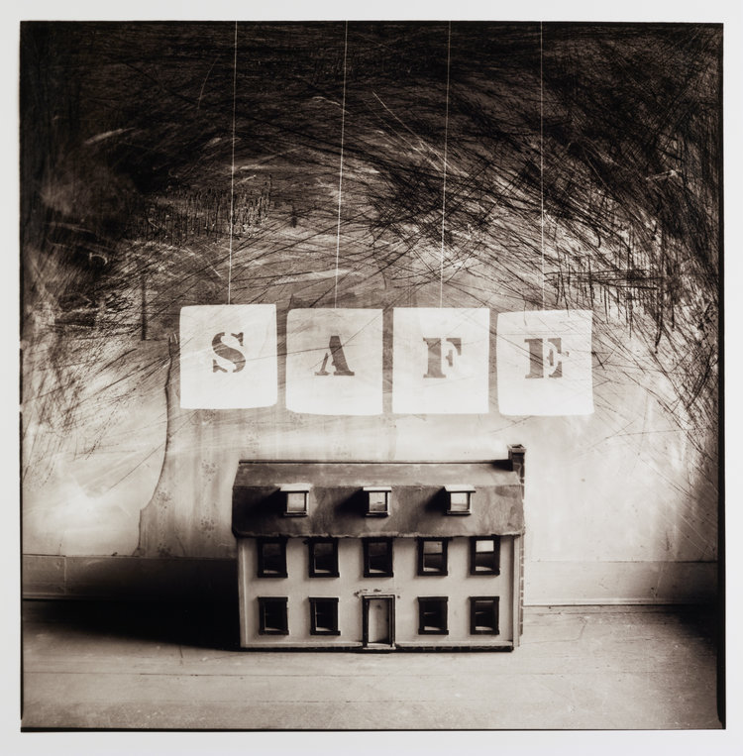
What: Four lectures by Front Range photographers
When: March 3, 17, 23 and 30. Doors at 6:30 p.m.
Where: Denver Art Museum, Hamilton Building Lower Level, 100 West 14th Avenue, Denver
Cost: $10 general admission, $5 DAM Members, Students and CPAC Members
The Lowdown: Four Front Range-based photographers will give individual lectures during the Month of Photography. Carol Golemboski will kick off the events on March 3, presenting her ideas through images that feel rough and nostalgic at once. On March 17, Andrew Beckham will take the stage with his contemplative photography that results in some naming him a “visual poet.” On March 23 it will be Gary Emrich, a fourth-generation Coloradan who depicts pop-culture icons with suitably bright compositions of found items. Closing out the series will be Benjamin Rasmussen, on March 30, who constantly questions the concepts of home, family, community and the environmental impacts we may create or be destroyed by.

Carol Golemboski, Safe, 2001

Environment and Nature
Andy Mann
What: National Geographic Nature and Adventure Photographer, Andy Mann
When: March 8—April 9, Wednesday-Thursday, 12—5 p.m., Friday 12—9 p.m., Saturday-Sunday 12—5 p.m.
Where: Firehouse Art Center, 667 4th Ave, Longmont
The Lowdown: Niwot resident Andy Mann has been an adventure and nature photographer for over a decade, contributing to National Geographic, The New York Times, Red Bull, Adidas and North Face—and has earned a reputation as an explorer obsessed with “firsts.” He brings along his camera and the results are captivating images of our changing and diverse world. His images often carry a sense of the adrenaline he must feel capturing them.

Barbara Gal
What: 71% of the Earth is Water, photographs and collages by Barbara Gal
When: March 12—April 2, Fridays 5—10 p.m., Saturday-Sunday 12—5 p.m.
Where: NEXT Art Gallery, 3659 Navajo St, Denver
The Lowdown: This will be the last show after 10 years at the Navajo Street location, before NEXT Gallery moves to the new location. Photographs by Barbara Gal will be displayed, showing various water formations around the world from interesting perspectives.

